* Over 232,000 women and 2,300 men will be diagnosed with breast cancer in the U. S. in 2014; 27 new cases are diagnosed every hour of every day.
* 80-85% of diagnoses have no family history.
* Every 13 minutes 1 woman in the U. S. dies of breast cancer, almost 40,000 a year.
* In 2013 there were more than 3 million breast cancer survivors in the U. S.
* 1 out of 8 women will be diagnosed with breast cancer.

I have been an advocate of breast cancer awareness for the past 24 years. On September 18, 2006 after my annual mammogram, I was 1 of the 8.

Bowling to Beat Breast Cancer, Inc. was formed to raise money to support breast cancer patients of Duluth-Superior hospitals. Along with promoting breast cancer awareness, this fundraiser will be held annually to raise money to continually purchase the book *Chicken Soup for the Breast Cancer Survivor’s Soul.* To date, over 1,900 books have been distributed to Essentia Health, St. Luke’s, and other breast cancer awareness functions. This book has made a great impact in my acceptance of breast cancer. My hope is that other breast cancer patients will find the same comfort that this book continues to give me.

The 7th annual Bowling to Beat Breast Cancer event held in October 2013 raised over $20,000, bringing total funds raised to over $96,000. Bowling to Beat Breast Cancer, Inc. became a non-profit 509(a) (2) on April 1, 2008.

I wish I could name and thank all the people who have and continue to give me encouragement and support. The list is endless; however, I believe you know who you are. I hope I can someday touch your life as you have touched mine. This event would not be possible without my “Fab Five.” A special thank you goes to Barb Lucia, Cindy Miller, Moe Miller, Pam Savoy, and Janice Stack. These five fabulous women have made me realize that I am *not* and will *never* be alone.

Thank you and make it a great day!

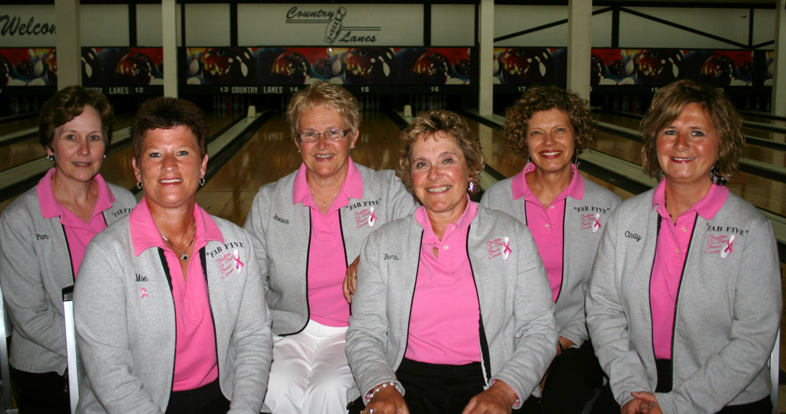

www.bowlingtobeatbreastcancer.com

Bowling to Beat Breast Cancer

1-C Scharte Drive

Superior WI 54880

Address Correction Requested

www.bowlingtobeatbreastcancer.com

  

A bowling fundraiser to support breast cancer patients of Duluth-Superior hospitals.

*With support from Major Sponsors*



A Message from Barb Hoag

**Saturday, October 18**

***OR***

**Sunday, October 19**

**2014**



Bowl for fun and prizes, while supporting breast cancer patients at Duluth-Superior hospitals.

* Get your team of 5 bowlers together and register now!

*OR*

* Sign up as an individual and you will be placed with other individuals to make a team of 5 bowlers.
* You choose the date you want to bowl:  
  Saturday, October 18   
  OR   
  Sunday, October 19
* 3 games of bowling, with prize awarded for a strike on the pink head pin (one prize per bowler).
* Sanction not required (not required to be a league bowler).
* Must be age 18 or over.
* Registration at 1:15 pm, with opening announcements at 1:45 pm.
* Bowling 2:00-4:30 pm, followed by a light supper, featuring Grandma’s Chicken Wild Rice Soup.
* Prize Drawing – Buy tickets for a chance to win some great prizes.

**Your *paid* *registration*   
reserves your spot!**

*Details*

**Team Registration Fee $125**

5-person teams at $25/person.  
*Your* paid *registration reserves your team’s spot.*

**Individual Registration Fee $25**

You will be placed with other bowlers  
to make a team of 5.  
*Your* paid *registration reserves your spot.*

**Lane Sponsor $100**

Sponsor a lane with a banner.

**Corporate Sponsor $225**

Lane sponsorship ($100) +   
team registration fee ($125).

**Prize Sponsor**

Donate prize(s) for the prize drawing.

**Placard Sponsor $10**

Recognize someone who has experienced  
breast cancer. Placards will be displayed  
in a prominent location.

**Donation**

Since Bowling to Beat Breast Cancer is a 509(a)(2) non-profit, your donation is tax-deductible.

**Special recognition for breast cancer survivors**

* A special bandana will be presented to all breast cancer survivors.
* Breast cancer survivors will roll the first ball on each day.

Registration fee is transferable, but not refundable.

**First come, first served.   
The first 24 teams with *paid* registration,   
per date, will be accepted.**

Questions: Call Barb at 218-348-8398

[www](http://www.bowlingtobeatbreastcancer.com).bowlingtobeatbreastcancer.com

**COUNTRY LANES NORTH**

2327 Mountain Shadow Drive

Duluth, Minnesota

218-722-1741

**Make checks payable to**:

Bowling to Beat Breast Cancer

**Mail registration form to**:

*Bowling to Beat Breast Cancer*

1-C Scharte Drive

Superior WI 54880

*Bowling To Beat   
Breast Cancer*

***Sign-up Form***

BOWLER REGISTRATION

A. Select one preferred date:

🞏 Saturday, October 18

🞏 Sunday, October 19

B. Choose Team OR Individual Registration by  
 marking the appropriate box below.

🞏TEAM REGISTRATION $125

Team Member Names

1. ______________________________________
2. ______________________________________
3. ______________________________________
4. ______________________________________
5. ______________________________________

Team Captain __________________________

Address _________________________________

_________________________________

Phone _________________________________

Email address ___________________________

🞏INDIVIDUAL REGISTRATION $25

Name _________________________________

Address _________________________________

_________________________________

Phone _________________________________

Email address ___________________________

* I am a BREAST CANCER SURVIVOR

Name _________________________________

🞏LANE SPONSOR $100

_________________________________________

Contact name/phone

🞏CORPORATE SPONSOR $225

_________________________________________

Contact name/phone

🞏PRIZE SPONSOR

_________________________________________

Contact name/phone

🞏PLACARD SPONSOR Each $10

In memory of (name) _________________________

In support of (name) _________________________

🞏DONATION $_________________